

Southern Luzon State University
COLLEGE OF ENGINEERING
Computer Engineering Department
Lucban, Quezon

CPE22L: Digital Signal Processing Laboratory

Activity # 5: Discrete Time Signals in the Frequency Domain

PADUADA, Dave Jhared G.

DOP: Oct 22, 2025
DOS: Oct 29, 2025

RATING

Engr. Ralph Monsour Delima
INSTRUCTOR

- Objectives
  - To learn the different properties of Discrete Time Fourier Transform (DTFT)
  - To identify the MATLAB codes used to generate DTFT of a function.
  - To understand the significance of DTFT in digital signal processing.
- Introductory Information

Discrete-time signals are obtained by the sampling of continuous-time signals – real valued functions of a real-valued time – at a constant rate. The analysis of many of their properties are simpler to carry out in the frequency domain once a Fourier Transform has been applied to the original data. The Fourier transform generates frequency functions in the classical environment. Sinusoidal signals, which have arguably the simplest frequency content, cannot be represented in the frequency domain. As a result, this hypothesis should be regarded as a partial failure, or at the very least unfinished.
In the previous exercises, we dealt with the time-domain representation of discrete-time signals and systems and investigated their properties. Further insight into the properties of such signals and systems is obtained by their representation in the frequency-domain. To this end three commonly used representations are the discrete-time Fourier transform (DTFT), the discrete Fourier transform (DFT), and the z-transform. In this exercise, we studied all the three representations of a discrete-time sequence.
- Data & Procedures

% Program P5_1  % Evaluation of the DTFT  clf;  % Compute the frequency samples of the DTFT  w = -4*pi:8*pi/511:4*pi;  num = [2 1]; den = [1 -0.6];  h = freqz(num, den, w);  % Plot the DTFT  subplot(2,1,1)  plot(w/pi, real(h));grid  title('Real part of H(e^{j\omega})')  xlabel('\omega /\pi');  ylabel('Amplitude');  subplot(2,1,2)  plot(w/pi,imag(h));grid  title('Imaginary part of H(e^{k\omega})')  xlabel('\omega /\pi');  ylabel('Amplitude');  pause  subplot(2,1,1)  plot(w/pi,abs(h));grid  title('Magnitude spectrum of |H(e^{k\omega})|')  xlabel('\omega /\pi');  ylabel('Amplitude');  subplot(2,1,2)  plot(w/pi,angle(h));grid  title('Phase spectrum arg[H(e^{k\omega})]')  xlabel('\omega /\pi');  ylabel('Phase, radians'); |  | %Program P5_2  %Time-Shifting Properties of DTFT  clf;  w = -pi:2*pi/255:pi; wo = 0.4*pi; D = 10;  num = [1 2 3 4 5 6 7 8 9];  h1 = freqz(num, 1, w);  h2 = freqz([zeros(1,D) num], 1 ,w);  subplot(2,2,1)  plot(w/pi, abs(h1));grid  title('Magnitude Spectrum of Original Sequence')  subplot(2,2,2)  plot(w/pi, abs(h2));grid  title('Magnitude Spectrum of Time-Shifted Sequence')  subplot(2,2,3)  plot(w/pi, angle(h1));grid  title('Phase Spectrum of Original Sequence')  subplot(2,2,4)  plot(w/pi, angle(h2));grid  title('Phase Spectrum of Time-Shifted Sequence')
%Program P5_3  %Frequency-Shifting Properties of DTFT  clf;  w = -pi:2*pi/255:pi; wo = 0.4*pi;  num1 = [1 3 5 7 9 11 13 15 17];  L = length(num1);  h1 = freqz(num1, 1, w);  n = 0:L-1;  num2 = exp(wo*i*n).*num1;  h2 = freqz(num2, 1, w);  subplot(2,2,1)  plot(w/pi, abs(h1));grid  title('Magnitude Spectrum of Original Sequence')  subplot(2,2,2)  plot(w/pi, abs(h2));grid  title('Magnitude Spectrum of Frequency-Shifted Sequence')  subplot(2,2,3)  plot(w/pi, angle(h1));grid  title('Phase Spectrum of Original Sequence')  subplot(2,2,4)  plot(w/pi, angle(h2));grid  title('Phase Spectrum of Frequency-Shifted Sequence') | %Program P5_4  %Convolution Property of DTFT  clf;  w = -pi:2*pi/255:pi;  x1 = [1 3 5 7 9 11 13 15 17];  x2 = [1 -2 3 -2 1];  y = conv(x1,x2);  h1 = freqz(x1, 1, w);  h2 = freqz(x2, 1, w);  hp = h1.*h2;  h3 = freqz(y,1,w);  subplot(2,2,1)  plot(w/pi,abs(hp));grid  title('Product of Magnitude Spectra')  subplot(2,2,2)  plot(w/pi,abs(h3));grid  title('Magnitude Spectrum of Convolved Sequence')  subplot(2,2,3)  plot(w/pi,angle(hp));grid  title('Sum of Phase Spectra')  subplot(2,2,4)  plot(w/pi, angle(h3));grid  title('Phase Spectrum of Convolved Sequence')
%Program P5_5  %Modulation Property of DTFT  clf;  w = -pi:2*pi/255:pi;  x1 = [1 3 5 7 9 11 13 15 17];  x2 = [1 -1 1 -1 1 -1 1 -1 1];  y = x1.*x2;  h1 = freqz(x1, 1, w);  h2 = freqz(x2, 1, w);  h3 = freqz(y, 1, w);  subplot(3,1,1)  plot(w/pi,abs(h1));grid  title('Magnitude Spectrum of First Sequence')  subplot(3,1,2)  plot(w/pi,abs(h2));grid  title('Magnitude Spectrum of Second Sequence')  subplot(3,1,3)  plot(w/pi,abs(h3));grid  title('Magnitude Spectrum of Product Sequence') | %Program P5_6  %Time Reversal Property of DTFT  clf;  w = -pi:2*pi/255:pi;  num = [1 2 3 4];  L = length(num)-1;  h1 = freqz(num, 1, w);  h2 = freqz(fliplr(num),1,w);  h3 = exp(w*L*i).*h2;  subplot(2,2,1)  plot(w/pi,abs(h1));grid  title('Magnitude Spectrum of Original Sequence')  subplot(2,2,2)  plot(w/pi,abs(h3));grid  title('Magnitude Spectrum of Time-Reversed Sequence')  subplot(2,2,3)  plot(w/pi,angle(h1));grid  title('Phase Spectrum of Original Sequence')  subplot(2,2,4)  plot(w/pi,angle(h3));grid  title('Phase Spectrum of Time-Reversed Sequence')

- Data and Results
Q5.1 What is the expression of the DTFT being evaluated in Program P5_1? What is the function of the MATLAB command pause? | The program evaluates the frequency response  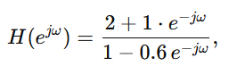  i.e. substitute $z=e^{jω}$into the transfer function with numerator coefficients num = [2 1] and denominator den = [1 -0.6].  The MATLAB command pause suspends execution until you press a key (or until an optional time elapses) , it lets you inspect the first set of plots before the script continues to overwrite them.
Q5.2 Run Program P5_1 and compute the real and imaginary parts of the DTFT, and the magnitude and phase spectra. Is the DTFT a periodic function of ω? If it is, what is the period? Explain the type of symmetries exhibited by the four plots. | 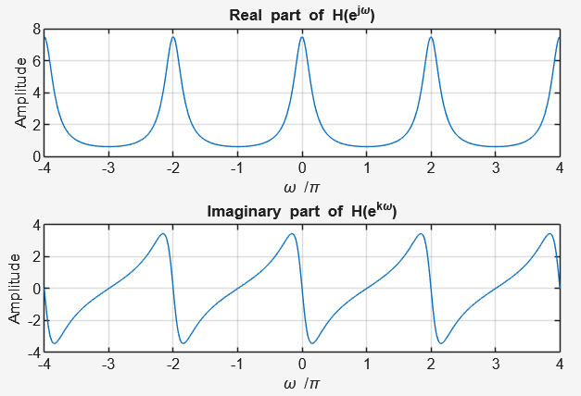  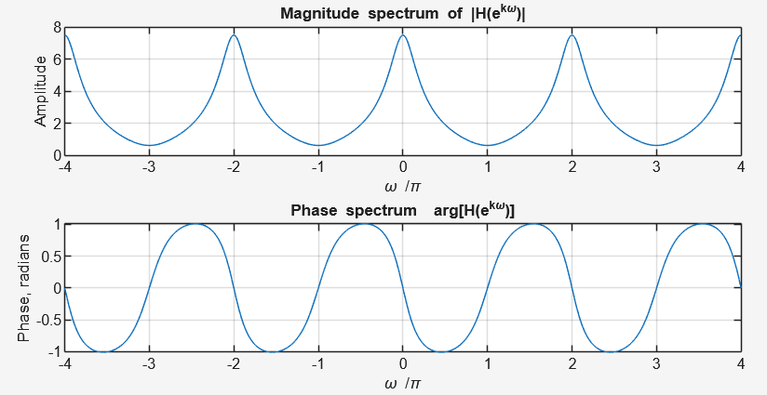  From the plots, the real part of $H(e^{jω})$is even (symmetric around ω = 0), while the imaginary part is odd (antisymmetric). This symmetry confirms that the system has real-valued coefficients in its difference equation. The DTFT is clearly a periodic function of ω with a period of 2π, as both the real and imaginary components repeat every 2π interval. These properties are consistent with the theoretical characteristics of discrete-time Fourier transforms for real-valued signals.
Q5.3 Modify Program P5_1 to evaluate in the range 0 ≤ ω ≤ π the following DTFT:  $$U(e^{jω}) =\frac{0.7 - 0.5e^{-jω} + 0.3e^{-2jω} + e^{-j3ω}}{1 + 0.3e^{-jω} - 0.5e^{-2jω} + 0.7e^{-j3ω}},$$  and repeat Question Q5.2. Comment on your results. Can you explain the jump in the phase spectrum ? The jump can be removed using the MATLAB command unwrap. Evaluate the phase spectrum with the jump removed. | 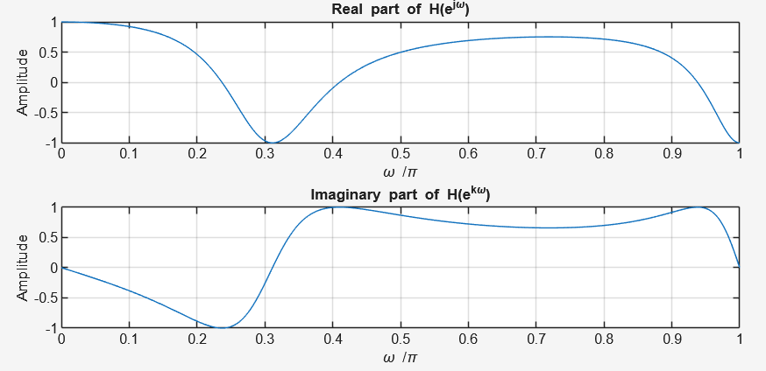  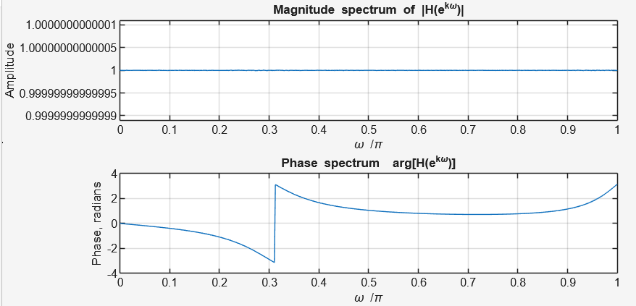  The plots show that the DTFT is still periodic but only evaluated over the range $0≤ω≤π$. The real part is even while the imaginary part is odd, indicating typical symmetry for real-valued sequences. The phase spectrum exhibits a jump due to the phase wrapping effect at discontinuities, which can be corrected using the MATLAB command unwrap to produce a smoother and continuous phase curve.
Q5.4 Modify Program P5_1 to evaluate the DTFT of the following finite-length sequence:  $$g[n]=[1 3 5 7 9 11 13 15 17],$$  and repeat Question Q5.2. Comment on your results. Can you explain the jumps in the  phase spectrum? | 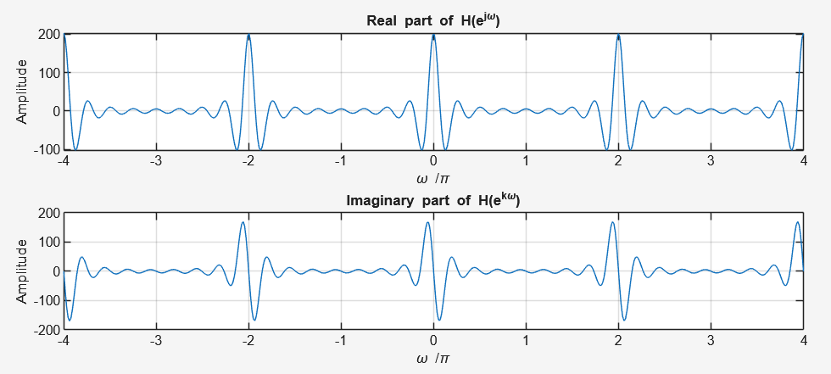  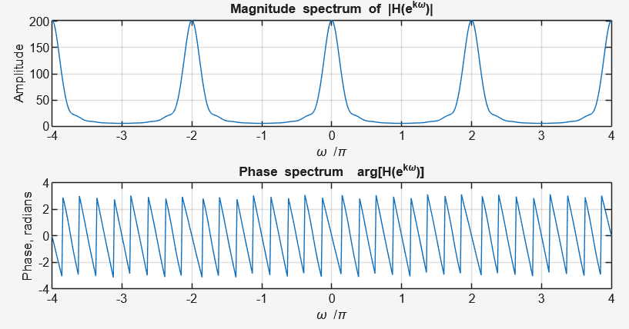  Because g[n] is real-valued, the same symmetry holds: real part even, imaginary part odd, magnitude even, phase odd (modulo wrapping). The jumps in the phase appear for the same reason as before — phase wrapping at ±π — and also may be pronounced near frequencies where the magnitude is very small (phase becomes numerically unstable there). Use unwrap(angle(H)) to display the continuous phase and better interpret the phase behaviour.
Q5.5 How would you modify Program P5_1 to plot the phase in degrees? | 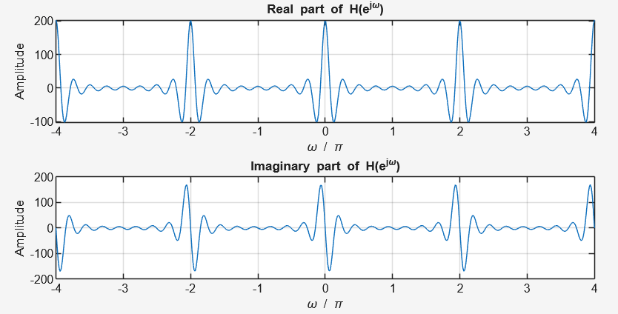  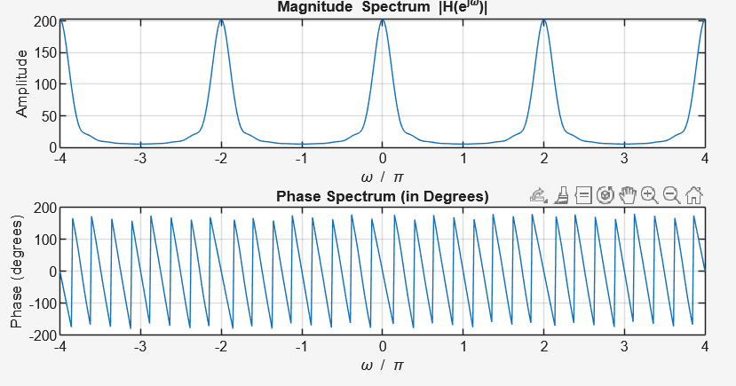  To modify the program so that the phase is plotted in degrees, multiply the result of angle(h) by 180/pi before plotting. This converts radians to degrees, making the phase plot easier to interpret.
Q5.6 Modify Program P5_2 by adding appropriate comment statements and program statements for labeling the two axes of each plot being generated by the program. Which parameter controls the amount of time-shift? | % Program P5_2 (Modified)  % Demonstration of the Time-Shifting Property of the DTFT  clc;  clear all;  close all;  % Define parameters  w = -pi:2*pi/255:pi; % Frequency range  wo = 0.4*pi;  D = 50;  % Define the original sequence  num = [1 2 3 4 5 6 7 8 9];  % Compute the DTFTs using freqz  h1 = freqz(num, 1, w); % DTFT of original sequence  h2 = freqz([zeros(1,D) num], 1, w); % DTFT of time-shifted sequence  % Plot the magnitude spectra  subplot(2,2,1)  plot(w/pi, abs(h1)); grid on;  title('Magnitude Spectrum of Original Sequence');  xlabel('\omega / \pi');  ylabel('Magnitude');  subplot(2,2,2)  plot(w/pi, abs(h2)); grid on;  title('Magnitude Spectrum of Time-Shifted Sequence');  xlabel('\omega / \pi');  ylabel('Magnitude');  % Plot the phase spectra  subplot(2,2,3)  plot(w/pi, angle(h1)); grid on;  title('Phase Spectrum of Original Sequence');  xlabel('\omega / \pi');  ylabel('Phase (radians)');  subplot(2,2,4)  plot(w/pi, angle(h2)); grid on;  title('Phase Spectrum of Time-Shifted Sequence');  xlabel('\omega / \pi');  ylabel('Phase (radians)');  The parameter that controls the amount of time-shift is D. Increasing D adds more zeros before the original sequence, shifting it further in time. The added comments and labels describe the axes for each plot, showing magnitude and phase versus normalized frequency (ω/π).
Q5.7 Run the modified program and comment on your results. | 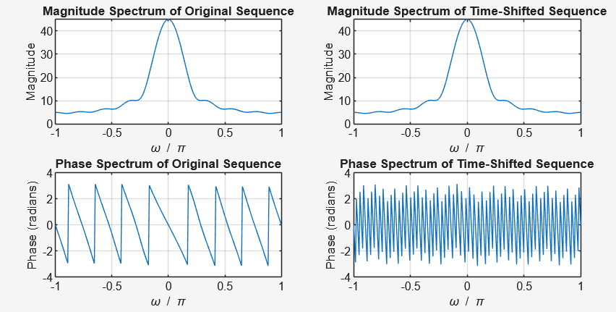  When the program is run, the magnitude spectrum remains the same for both the original and time-shifted sequences. However, the phase spectrum changes, showing a linear phase shift proportional to the value of D. This confirms that time-shifting a signal only affects the phase of its DTFT.
Q5.8 Repeat Question Q5.7 for a different value of the time-shift. | 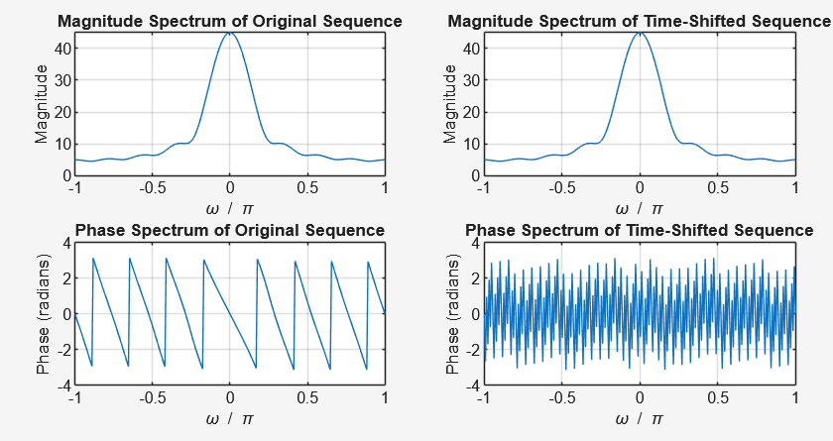  D = 100  If D is changed to a different value, the phase shift changes proportionally. A larger D causes a steeper linear shift in the phase plot, while the magnitude spectrum remains unchanged, reinforcing the time-shift property.
Q5.9 Repeat Question Q5.7 for two different sequences of varying lengths and two different time-shifts. | 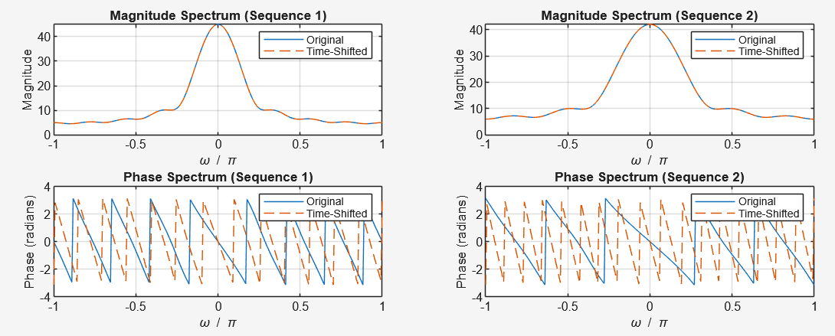  When the sequences have different lengths or different shifts, the magnitude spectra vary based on sequence length, and their phase plots show distinct phase slopes depending on their respective time shifts. This demonstrates that the phase behavior is sensitive to time-shift amount, while the magnitude reflects the overall signal structure.
Q5.10 Modify Program P5_3 by adding appropriate comment statements and program statements for labeling the two axes of each plot being generated by the program. Which parameter controls the amount of frequency-shift? | % Program P5_3 (Modified for Q5.13)  % Frequency-Shifting Properties of DTFT  % Compare two sequences with different lengths and frequency shifts  clc;  clear all;  close all;  % ----- Frequency range -----  w = -pi:2*pi/255:pi;  % ----- First sequence -----  num1 = [1 3 5 7 9 11 13 15 17]; % Original sequence 1  wo1 = 0.4*pi; % First frequency shift (radians)  L1 = length(num1);  n1 = 0:L1-1;  % Frequency shift applied using complex exponential modulation  num1_shifted = exp(1j*wo1*n1).*num1;  % Compute DTFTs  h1_orig = freqz(num1, 1, w);  h1_shift = freqz(num1_shifted, 1, w);  % ----- Second sequence -----  num2 = [2 4 6 8 10 12]; % Second sequence (shorter)  wo2 = 0.7*pi; % Second frequency shift (different)  L2 = length(num2);  n2 = 0:L2-1;  num2_shifted = exp(1j*wo2*n2).*num2;  % Compute DTFTs  h2_orig = freqz(num2, 1, w);  h2_shift = freqz(num2_shifted, 1, w);  % ----- Plot Results -----  figure;  subplot(2,2,1)  plot(w/pi, abs(h1_orig)); hold on; plot(w/pi, abs(h1_shift), '--');  grid on;  title('Magnitude Spectrum (Sequence 1)');  xlabel('\omega / \pi');  ylabel('Magnitude');  legend('Original','Frequency-Shifted');  subplot(2,2,2)  plot(w/pi, abs(h2_orig)); hold on; plot(w/pi, abs(h2_shift), '--');  grid on;  title('Magnitude Spectrum (Sequence 2)');  xlabel('\omega / \pi');  ylabel('Magnitude');  legend('Original','Frequency-Shifted');  subplot(2,2,3)  plot(w/pi, angle(h1_orig)); hold on; plot(w/pi, angle(h1_shift), '--');  grid on;  title('Phase Spectrum (Sequence 1)');  xlabel('\omega / \pi');  ylabel('Phase (radians)');  legend('Original','Frequency-Shifted');  subplot(2,2,4)  plot(w/pi, angle(h2_orig)); hold on; plot(w/pi, angle(h2_shift), '--');  grid on;  title('Phase Spectrum (Sequence 2)');  xlabel('\omega / \pi');  ylabel('Phase (radians)');  legend('Original','Frequency-Shifted');
Q5.11 Run the modified program and comment on your results. | 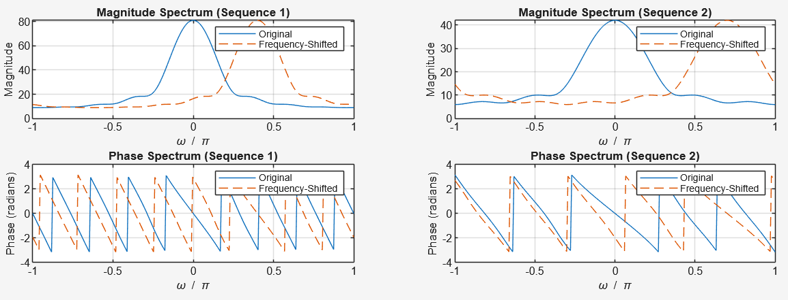  When you run the program, you’ll see that the magnitude spectrum is shifted horizontally (along ω), while the phase also changes accordingly. The shape remains the same — only its position in frequency shifts.
Q5.12 Repeat Question Q5.11 for a different value of the frequency-shift. | 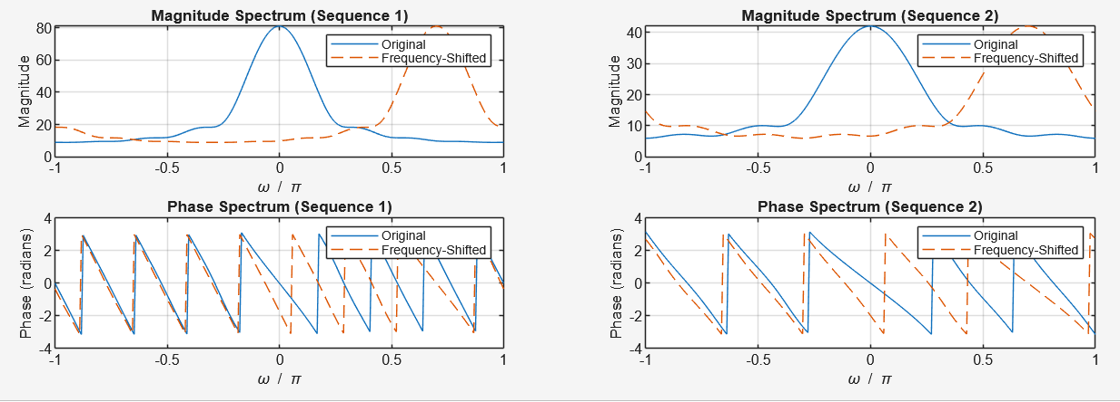  Changing wo to a different value (e.g., from 0.4π to 0.7π) causes the spectrum to shift by a different amount. Larger wo → greater frequency shift.
Q5.13 Repeat Question Q5.11 for two different sequences of varying lengths and two different frequency-shifts. | % ----- First sequence -----  x1 = [1 2 3 4 5 6 7 8]; % Sequence 1  wo1 = 0.3*pi; % Frequency shift 1  % ----- Second sequence -----  x2 = [2 4 6 8 10 12 14 16 18 20]; % Sequence 2 (longer)  wo2 = 0.6*pi; % Frequency shift 2  L2 = length(x2);  n2 = 0:L2-1;  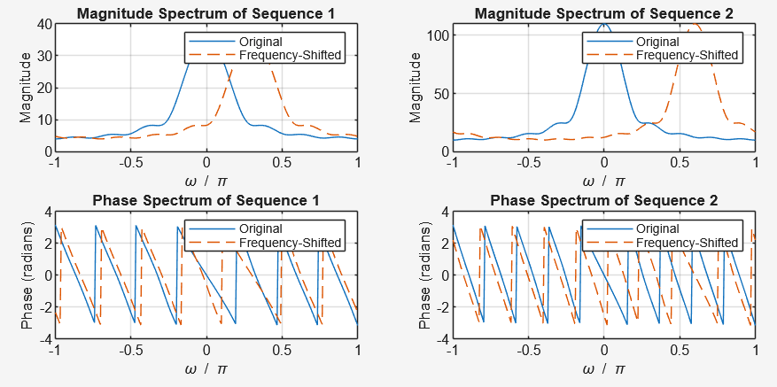  When using two sequences of varying lengths, the shorter one has a broader frequency spectrum, while the longer one shows narrower, more defined peaks. The amount of frequency shift still depends on wo.
Q5.14 Modify Program P5_4 by adding appropriate comment statements and program statements for labeling the two axes of each plot being generated by the program. | % Program P5_4 (Modified)  % Convolution Property of DTFT  % Demonstrates that convolution in time corresponds to multiplication in frequency  clc;  clear all;  close all;  % ----- Frequency range -----  w = -pi:2*pi/255:pi;  % ----- Input sequences -----  x1 = [1 3 5 7 9 11 13 15 17]; % First sequence  x2 = [1 -2 3 -2 1]; % Second sequence  % ----- Convolution in time domain -----  y = conv(x1, x2);  % ----- DTFT (using freqz) -----  h1 = freqz(x1, 1, w); % DTFT of x1[n]  h2 = freqz(x2, 1, w); % DTFT of x2[n]  hp = h1 .* h2; % Product in frequency domain  h3 = freqz(y, 1, w); % DTFT of convolved sequence  % ----- Plotting -----  subplot(2,2,1);  plot(w/pi, abs(hp)); grid on;  title('Product of Magnitude Spectra');  xlabel('\omega / \pi');  ylabel('Magnitude');  subplot(2,2,2);  plot(w/pi, abs(h3)); grid on;  title('Magnitude Spectrum of Convolved Sequence');  xlabel('\omega / \pi');  ylabel('Magnitude');  subplot(2,2,3);  plot(w/pi, angle(hp)); grid on;  title('Sum of Phase Spectra');  xlabel('\omega / \pi');  ylabel('Phase (radians)');  subplot(2,2,4);  plot(w/pi, angle(h3)); grid on;  title('Phase Spectrum of Convolved Sequence');  xlabel('\omega / \pi');  ylabel('Phase (radians)');
Q5.15 Run the modified program and comment on your results. | 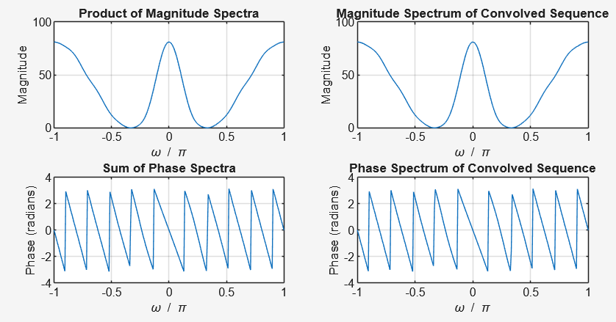  When the program is run, the magnitude spectrum of the convolved signal (|H₃|) closely matches the product of the individual magnitude spectra (|H₁|·|H₂|).  Similarly, the phase spectrum of the convolution corresponds to the sum of the individual phase spectra, verifying the convolution property of DTFT.
Q5.16 Repeat Question Q5.15 for two different sets of sequences of varying lengths. | x1 = [2 4 6 8 10 12 14 5 16]; % First sequence  x2 = [1 1 -1 -1]; % Second sequence  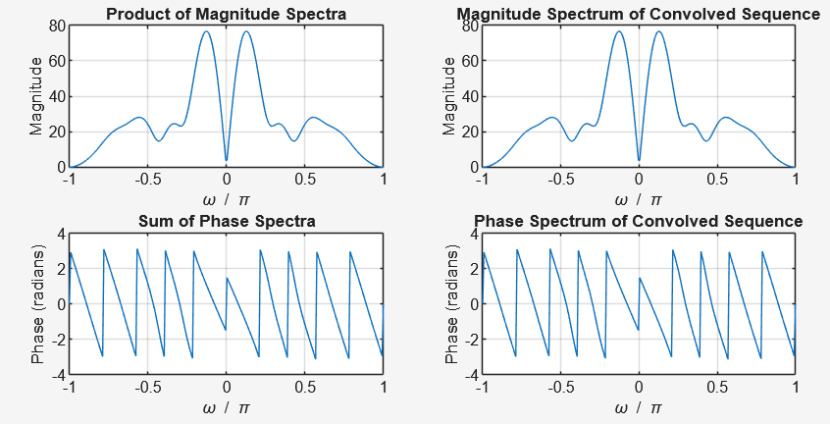
Q5.17 Modify Program P5_5 by adding appropriate comment statements and program statements for labeling the two axes of each plot being generated by the program. | % Program P5_5 (Modified)  % Modulation Property of DTFT  % Demonstrates that multiplication in time corresponds to convolution in frequency  clc;  clear all;  close all;  % ----- Frequency range -----  w = -pi:2*pi/255:pi;  % ----- Input sequences -----  x1 = [1 3 5 7 9 11 13 15 17]; % First sequence  x2 = [1 -1 1 -1 1 -1 1 -1 1]; % Second sequence (modulating signal)  % ----- Time-domain multiplication (modulation) -----  y = x1 .* x2; % Element-wise multiplication  % ----- Compute DTFTs -----  h1 = freqz(x1, 1, w); % DTFT of first sequence  h2 = freqz(x2, 1, w); % DTFT of second sequence  h3 = freqz(y, 1, w); % DTFT of product sequence  % ----- Plot results -----  subplot(3,1,1);  plot(w/pi, abs(h1)); grid on;  title('Magnitude Spectrum of First Sequence');  xlabel('\omega / \pi');  ylabel('Magnitude');  subplot(3,1,2);  plot(w/pi, abs(h2)); grid on;  title('Magnitude Spectrum of Second Sequence');  xlabel('\omega / \pi');  ylabel('Magnitude');  subplot(3,1,3);  plot(w/pi, abs(h3)); grid on;  title('Magnitude Spectrum of Product Sequence (Time-Domain Modulation)');  xlabel('\omega / \pi');  ylabel('Magnitude');
Q5.18 Run the modified program and comment on your results. | 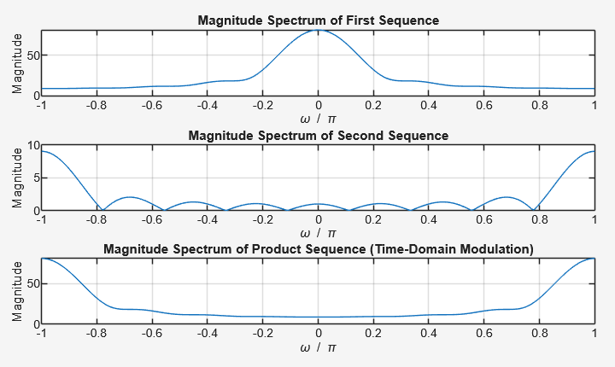  When the program runs, you’ll notice that the magnitude spectrum of the product sequence (y) looks like a frequency-shifted or spread version of the original.  This confirms the modulation property, multiplication in the time domain corresponds to convolution in the frequency domain, which shifts or redistributes the spectrum.
Q5.19 Repeat Question Q5.18 for two different sets of sequences of varying lengths. | 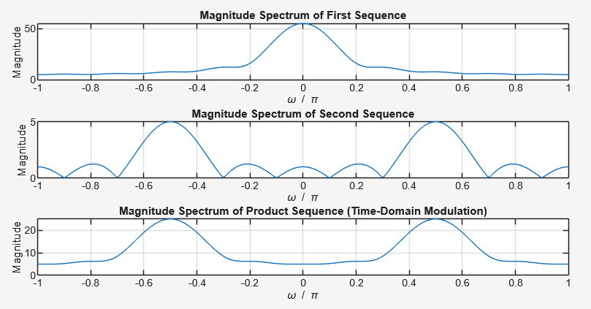  Each variation will produce a different frequency convolution pattern, but the overall principle remains: Multiplying signals in time shifts or spreads their frequency components.
Q5.20 Modify Program P5_6 by adding appropriate comment statements and program statements for labeling the two axes of each plot being generated by the program. Explain how the program implements the time-reversal operation. | % Program P5_6 (Modified)  % Time Reversal Property of DTFT  % Demonstrates how reversing a signal in time affects its DTFT magnitude and phase  clc;  clear all;  close all;  % ----- Frequency range -----  w = -pi:2*pi/255:pi; % Frequency vector from -π to π  % ----- Original sequence -----  num = [1 2 3 4];  L = length(num) - 1;  % ----- Compute DTFT of the original sequence -----  h1 = freqz(num, 1, w);  % ----- Time-reversal operation -----  % fliplr(num) reverses the sequence in time  h2 = freqz(fliplr(num), 1, w);  % ----- Apply time-reversal phase correction -----  % The exponential term e^(jωL) compensates for index shift due to reversal  h3 = exp(1i * w * L) .* h2;  % ----- Plot magnitude spectra -----  subplot(2,2,1);  plot(w/pi, abs(h1)); grid on;  title('Magnitude Spectrum of Original Sequence');  xlabel('\omega / \pi');  ylabel('Magnitude');  subplot(2,2,2);  plot(w/pi, abs(h3)); grid on;  title('Magnitude Spectrum of Time-Reversed Sequence');  xlabel('\omega / \pi');  ylabel('Magnitude');  % ----- Plot phase spectra -----  subplot(2,2,3);  plot(w/pi, angle(h1)); grid on;  title('Phase Spectrum of Original Sequence');  xlabel('\omega / \pi');  ylabel('Phase (radians)');  subplot(2,2,4);  plot(w/pi, angle(h3)); grid on;  title('Phase Spectrum of Time-Reversed Sequence');  xlabel('\omega / \pi');  ylabel('Phase (radians)');  The time-reversal operation is implemented using the MATLAB function fliplr(num), which reverses the order of elements in the sequence num.  This corresponds to x(-n) in discrete time.  The exponential term exp(1i*w*L) is applied to correct the phase shift introduced by the reversal, aligning the reversed sequence in the frequency domain.  In essence:  Reversing a signal in time mirrors its phase spectrum around the origin, while the magnitude spectrum remains unchanged.
Q5.21 Run the modified program and comment on your results. | 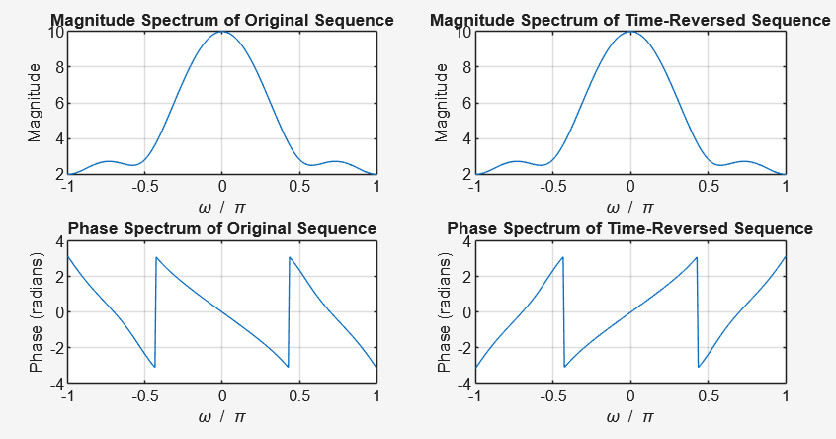  The magnitude spectra of the original and time-reversed sequences look identical , showing that time reversal doesn’t affect magnitude.  The phase spectra, however, are mirrored (flipped) about the vertical axis, confirming the time-reversal property of DTFT.  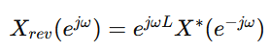
Q5.22 Repeat Question Q5.21 for two different sequences of varying lengths. | 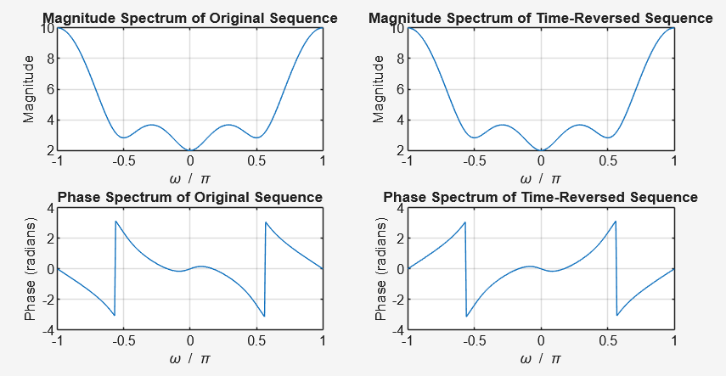  num = [2 -1 4 -3];  The magnitude spectrum shape changes (due to different signal content), But the time-reversal effect remains the same,mirrored phase and identical magnitude symmetry.

- Conclusion
In this laboratory activity, I was able to explore and understand the different properties of the Discrete Time Fourier Transform (DTFT), including time-shifting, frequency-shifting, convolution, modulation, and time-reversal. Through the use of MATLAB programs, I learned how to generate and analyze the DTFT of various discrete-time sequences. Each program demonstrated how specific signal operations affect the magnitude and phase spectra in the frequency domain. This activity helped me recognize the importance of DTFT as a fundamental tool in digital signal processing, allowing signals to be analyzed, modified, and interpreted more effectively in terms of their frequency content.

